Daniel Gopal

**Level 1: PC Tower Case**

**Outline**

Learn about the internals of a standard PC case by examining physical samples and selecting and labeling images found on-line. Gain deeper knowledge by researching and reporting on specific components.

**Questions**

1. Find one (or more) images that clearly show the internals of a PC Tower Case.   
   (i.e. Google images using keywords “PC Case Internals”)
2. Clearly label the following components (using arrows) on your image of the PC case internals:
   1. Motherboard
   2. Power Supply
   3. Hard Disk Drive
   4. Optical Disk Drive (e.g.DVD)
   5. USB Expansion Ports
   6. Monitor Port
   7. Audio Ports
   8. Ethernet Port

i. Cooling Fan

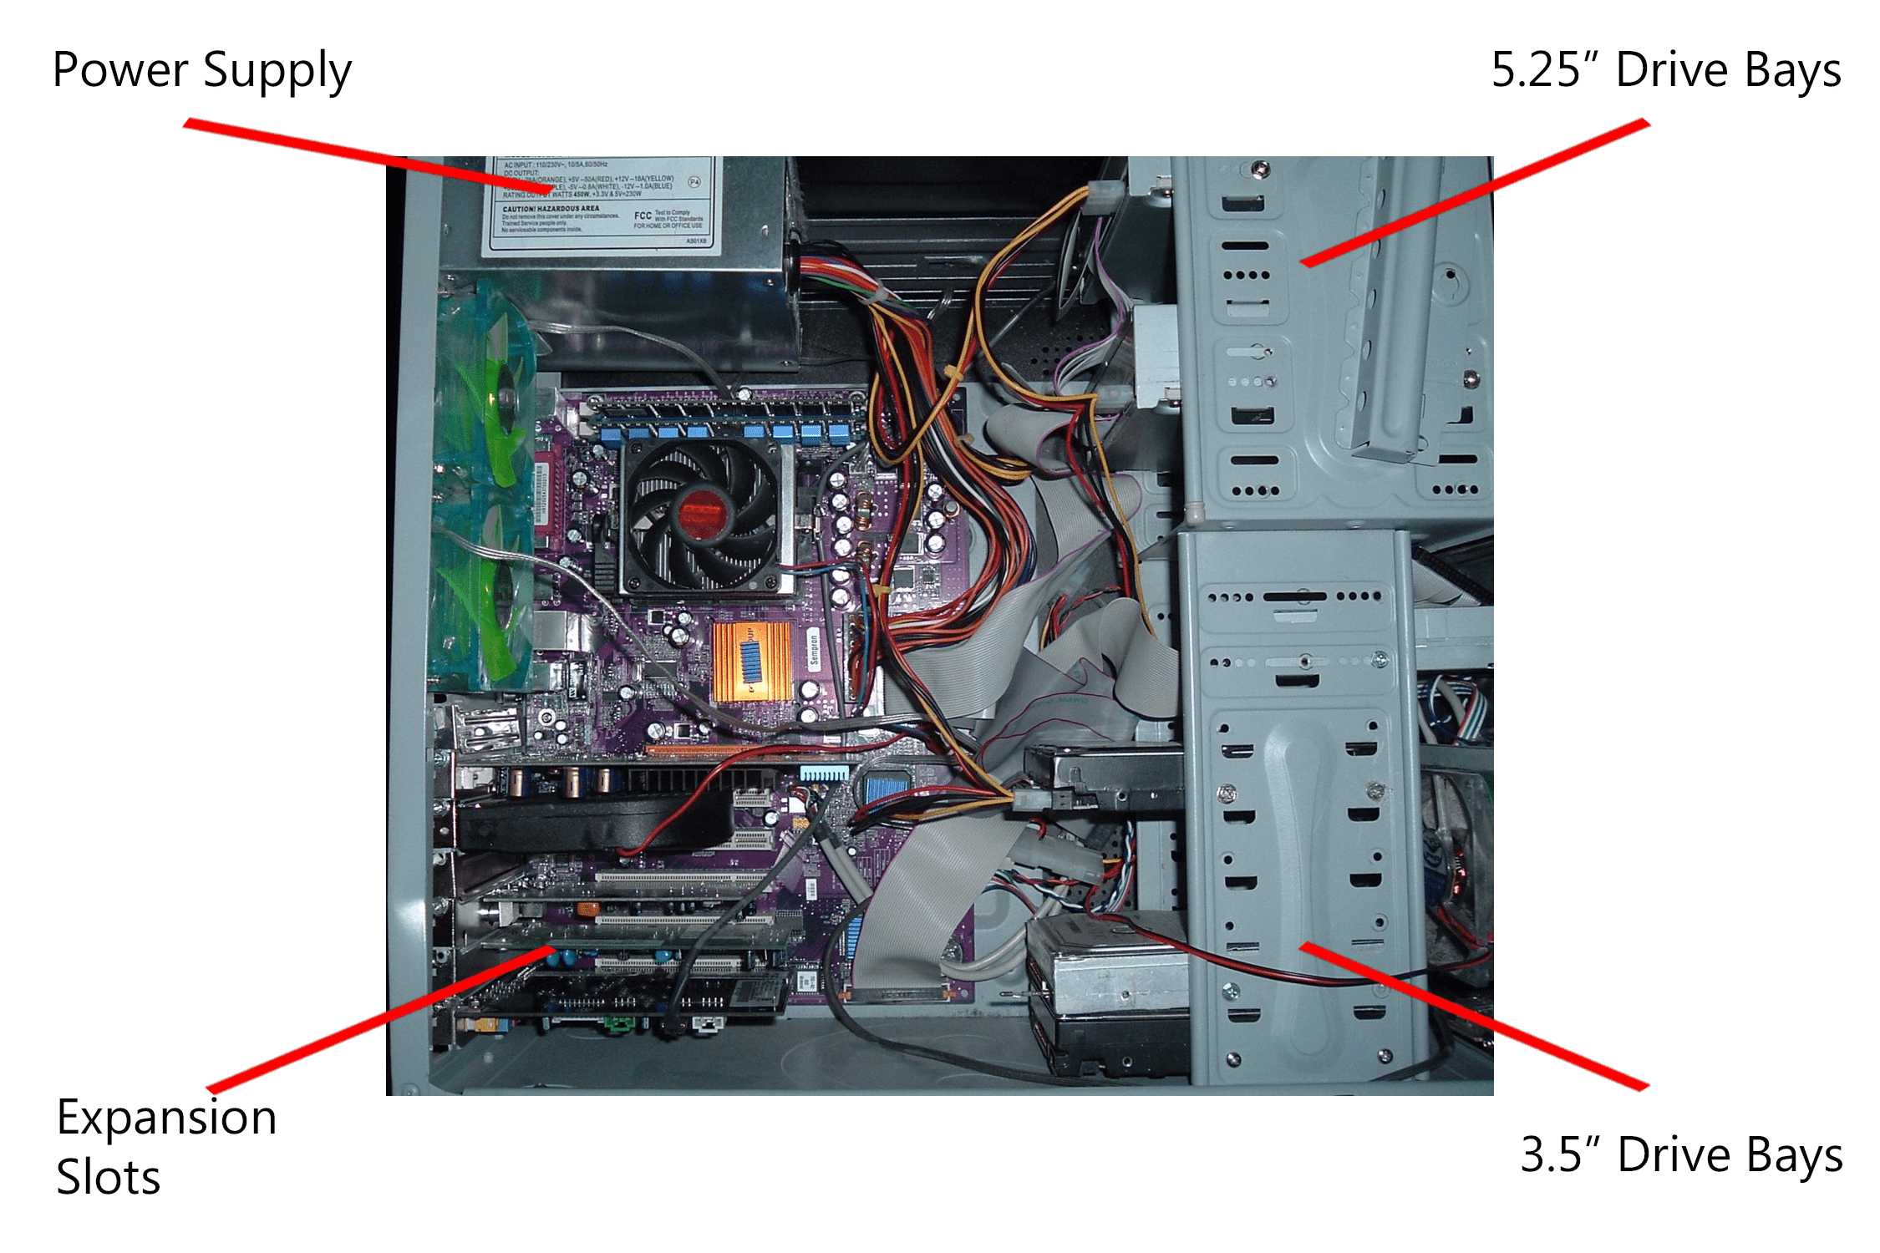

Hard Disk Drive

DVD/CD Drive

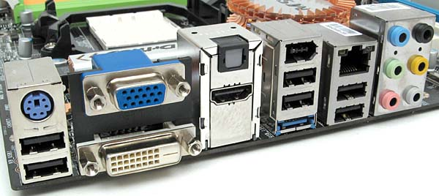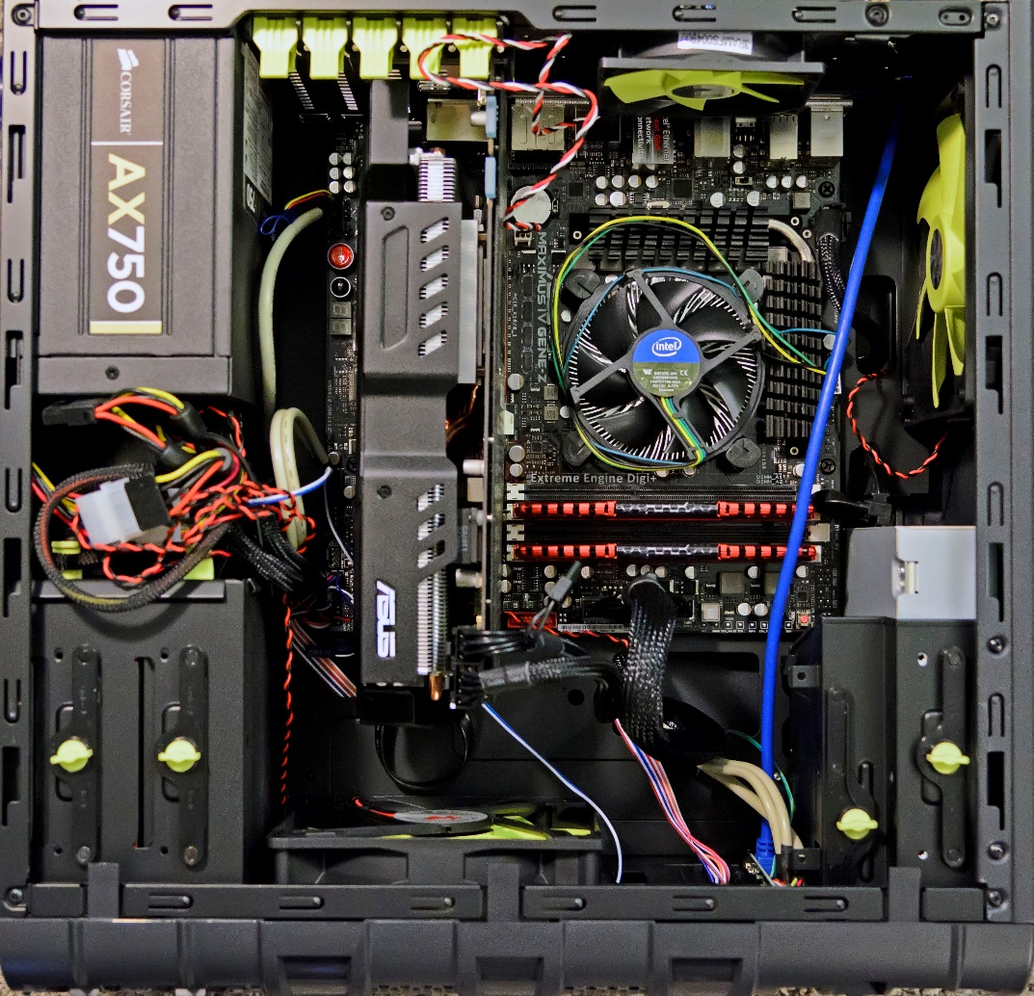

Motherboard

Graphics/video card on PCI slot

Hard drive bay

Ethernet

RS-Out

Line-in

Line-out

CS-Out

SS-Out

Mic

HDMI port

DVI-D port

VGA port

Usb 2.0 ports

eSATA port

Power Supply (PSU)

Memory Slot/RAM

CPU (underfan)

CPU fan/heatsink ICS3C Module A.4: Computing History Name: Daniel Gopal

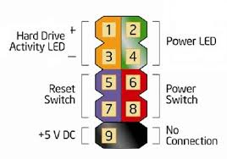

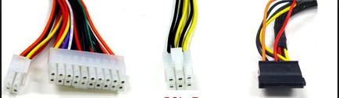

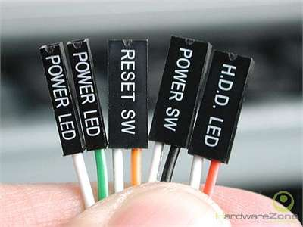

20+4Pin

SATA

PCI-E Connectors

Front panel Connectors

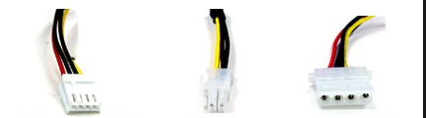

Floppy Connectors

P4 MB Connectors

4Pin Molex connectors

1. Research more in-depth about “Motherboards”. Make notes on the following:
   1. What different versions are currently available (speed and capacity)

When looking at the RAM capacity on motherboards, they usually range from lower-end models supporting up to rarely 32gb and rarely some 16gb wile as a higher end model can do anything from 64gb to even 128gb. RAM speeds such as 1600 MHZ, 1866 MHZ, 2133 MHZ, 2400 MHZ, 2800 MHZ, 2933 MHZ, and even 3200 MHZ can vary depending on the motherboard’s compatibility.

* 1. How the component has changed since the 1980’s  
     Current Motherboards are overall much more simplified than the complex engineering that older boards present to its users to work with. As we now live in a computer market where many users decide to build their personal computers instead of purchasing a pre-built one that would obviously cost more. Vintage motherboards tend to have built in RAM and even CPUs then the varied flexibility and compatibility that today’s motherboards offer. Another big change is built in components and functions such built in back panel ports for external devices (monitor, speakers, keyboard, and mouse) or even built in WIFI and ethernet. By which in the past many users had to purchase external cards just to use these new features when they were first adapted to then popularity.

1. Research more in-depth about “Hard Disk Drives”. Make notes on the following:
   1. What different versions are currently available (speed and capacity)

Today’s hard drives still perform very well for the average usage in both for example, text-based work which can be less performance intensive when compared to something like gaming. Which games do perform better with an expensive and high-end drive like a Solid-State Drive (SSD). However, average HDD’s that run at 5400 RPM and even 7200 RPM are proven run games still very well on new consoles like the PlayStation 4 and Xbox One. Most hard drives sold usually start from 500GB. A standard or healthy average people intend to favor in their hard drive capacity is usually in TBs and can go all the way up to 16TB for the purpose of saving very large files. They are sold in the form for external use through a USB based connection through the drives data port and for internal use within computer systems.

* 1. How the component has changed since the 1980’s  
     Some computers in the 80s did not support hard drives like for example, the IBM model number 5150 which released on August 12, 1981. By which it was not as powerful as many of the other personal computers it was competing against and had no hard drive support. Vintage Hard Drives were very large and bulky for the space they used up. They were usually made in Megabytes and soon later adapted to the tenths then Hundreds in Gigabytes. More forward, older HDDs used an IDE connection to connect to the computer motherboard. While as more current hard drives today use different interface called a SATA connection from the motherboard which is proven to be faster in transfer rate. When you really compare them, the newer drives are much more energy efficient, faster, and more versatile in the amount of hardware storage per weight.

**Level 2: PC Motherboard**

**Outline**

Learn about the structure of a standard PC motherboard by examining physical samples and selecting and labeling images found on-line. Gain deeper knowledge by researching and reporting on specific components.

**Questions**

1. Find one (or more) images that clearly show the layout of a PC Motherboard.   
   (i.e. Google images using keywords “PC Motherboard”)
2. Clearly label the following components (using arrows) on your image of the PC motherboard:
   1. CPU (and fan)
   2. RAM Memory
   3. Disk Drive Interface (IDE or SATA)
   4. GPU Graphics Processor (either on-board or Graphics Card)
   5. Sound Processor (either on-board or Sound Card)
   6. Wi-Fi / Ethernet Network Interface (either on-board or Graphics Card)

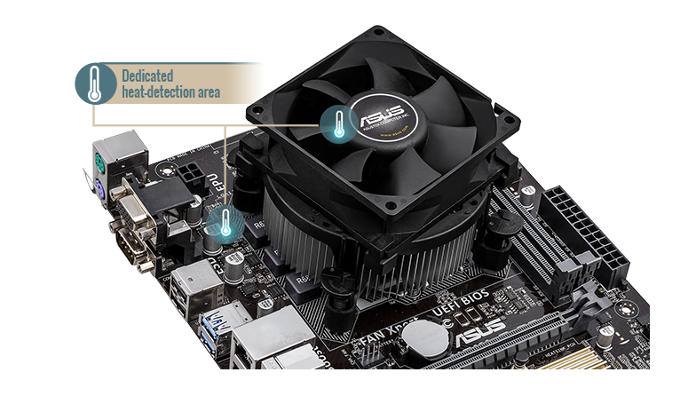

CPU(underfan)

CPU fan/heatsink ICS3C Module A.4: Computing History Name: Daniel Gopal

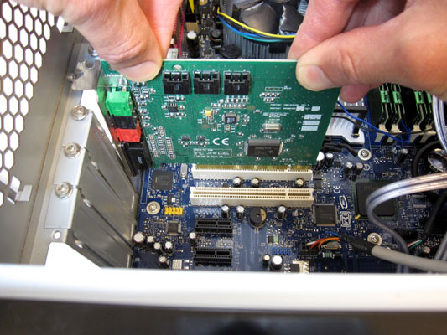

PCI slot

Sound Card

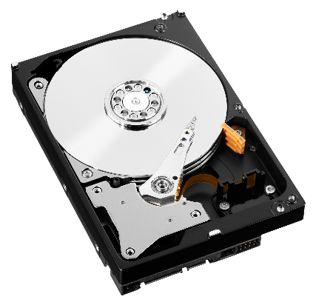

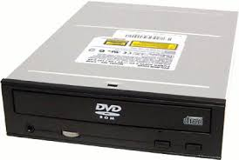

SATA

DVD Drive

Hard drive



CPU fan/heatsink ICS3C Module A.4: Computing History Name: Daniel Gopal

CPU (underfan)

Memory slot/RAM Computing History Name: Daniel Gopal

Power Supply (PSU)

Graphics/video card on PCI slot

Hard drive bay

Motherboard

1. Research more in-depth about “CPU Processor Chip”. Make notes on the following:
   1. What different versions are currently available (speed and capacity)

Currently dual core processors that were released years ago are still being sold as a low end and budget form of hardware. What is really high end in performance today in innovation is the Quad Core, Hexa (6) Core, and Octa (8) core CPUs run a range of clock speeds from 1ghz to 5ghz. These of course can be overclocked where you can override the CPU settings and increase speed and performance but build more heat through your computer setup. Most of these processors have between 1 and 4MB of cache. Most CPUs being sold are equipped with a built-in graphics chip that allows for the optional use of a graphics card to display an output.

* 1. How the component has changed since the 1980’s

Most CPUs being sold are equipped with a built-in graphics chip that allows for the optional use of a graphics card to display an output. As in the past it was quite mandatory to have one connected to display images and video on screen. Overall, processing speeds have now increased from a measurement of what was MHZ to now GHZ, they are definitely a lot smaller compared to their older counterparts and are much more efficient.

1. Research more in-depth about “RAM Memory”. Make notes on the following:

Memory can easily be classified into two major categories, Static RAM, and Dynamic RAM.

Single Data Rate SDRAM (one of the first memory architectures to support Synchronous Memory architectures).

Double Data Rate SDRAM (DDR improved upon the SDR design by providing double the data during one clock cycle: One word of data during the positive edge and one word of data during the negative edge of the clock pulse in which provided a significant increase in performance over the traditional architecture).

DDR2 SDRAM (Improvements were made in memory bandwidth, clock rates, and voltages).

DDR3 SDRAM (primarily increased the clock rates possible while reducing the voltages & latencies also increased significantly so there were only 2-5% performance gains).

DDR4 SDRAM (greater range of available clock speeds and timings, lower power consumption, and reduced latency).

**Level 3: Peripheral Devices**

**Outline**

Learn about how peripheral devices are connected to the back side of a typical PC tower case. Examine physical samples, select and labeling images found on-line and gain deeper knowledge by researching and reporting on specific components.

**Questions**

1. Find one (or more) images that clearly show the layout of the back of a typical PC tower case.   
   (i.e. Google images using keywords “Back Of PC Tower”)
2. Clearly label the following components (using arrows) on your image of the back of a typical PC tower case:
   1. Power cord and power switch
   2. Monitor Interface (VGA or DVI or HDMI)
   3. Mouse Interface (USB or PS/2)
   4. Keyboard Interface (USB or PS/2)
   5. USB Ports
   6. Audio Inputs / Outputs
   7. Ethernet Interface

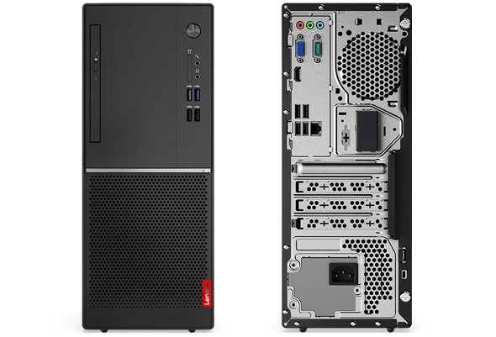

Line In, Line Out, Mic

Ethernet

USB Ports

VGA

Power Port

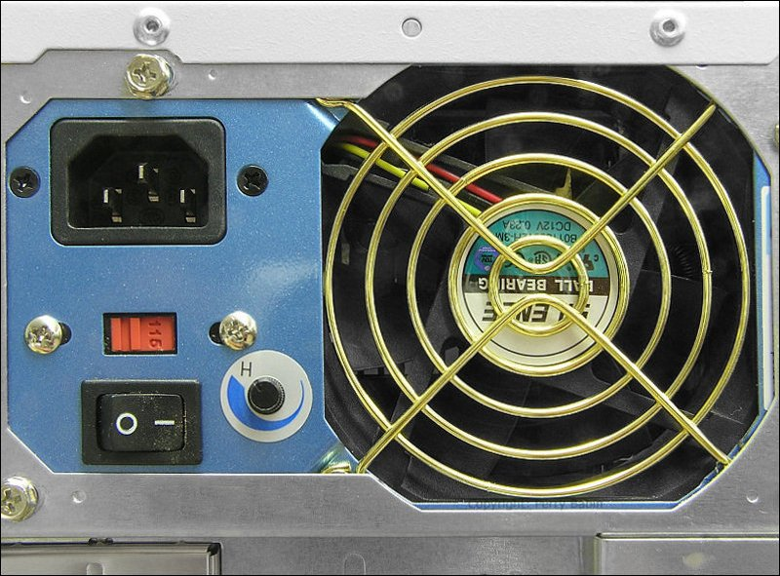

Power Switch

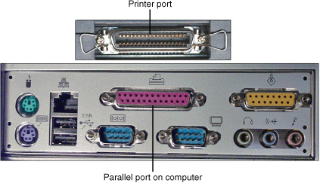

Keyboard

Mouse

1. Research more in-depth about “Monitor Technology”. Make notes on the following:

There was a huge transition from 2d to the innovation of 3d images. Same with overall color quality and contrast within these video technologies. The video resolutions became higher as older monitors where CRT that at the time supported standard definition (144p, 240p, 360p, and 480p). That had similar refresh rates to most TVs manufactured today being 60HZ. Now we have display panels built using LCDs that evolved into LEDs and now OLEDs. Providing higher resolutions in 4k (2160p), 1440p, HD 1080p, and even 720p. They support higher refresh rates such as 144Hz and 240Hz that is found more in hardcore and competitive gaming. Newer displays are capable of support almost every old resolution as they are upscaled and formatted to provide even the lowest of video qualities viewable. When you think about these components and features offered, they became more cheaper and affordable for the specifications sold over time.

1. Research more in-depth about “External Portable Storage”. Make notes on the following:
   1. Floppy Disks

A floppy disk also can be called floppy is a disc storage type that is thin and flexible with magnetic storage that is sealed in a rectangular plastic enclosure lined with fabric that is used to remove dust particles. They are read and written by a floppy disk drive. The floppy disk was first created in 1967 by IBM as an alternative to buying hard drives, which were very expensive at the time.

* 1. CD-ROM / DVD / Recordable CD/DVD

**CD-ROM:** Short for Compact Disc-Read Only Memory, a CD-ROM is an optical disc, which contains audio or software data in which the memory is read only. A CD-ROM Drive or optical drive is the device used to read them. CD-ROM drives have speeds ranging from 1x all the way up to 72x, meaning it reads the CD around 72 times faster than the 1x version. These drives are capable of playing audio CDs and reading data CDs, including CD-R and CD-RW discs.

**DVD:** Short for Digital Versatile Disc or Digital Video Disc, a DVD is a disc capable of storing large amounts of data on one disc the size of a standard Compact Disc. CD/DVD drives were first sold in 1997. They are widely used for storing and viewing films and other data.

* 1. USB Memory Drives

Alternatively referred to as a USB flash drive, data stick, pen drive, memory unit, key chain drive and thumb drive or a jump drive. They are a portable storage device that is often the size of a human thumb and connects to a computer through a USB port. Flash drives are an easy way to store and transfer data. They are available in sizes ranging from 1 GB to 1 TB. Unlike a standard hard drive, the flash drive has no movable parts and it contains only an integrated circuit memory chip that is used to store data. Flash drives usually have plastic or aluminum casings surrounding the memory chip and a USB connector for use with most modern computers.

* 1. Compact Flash Memory

Referred to in short form as CF is a 50-pin connection storage device. Compact Flash is a storage medium commonly found in PDAs like digital cameras, and other portable devices. The CF card has a large range of sizes in terms of storage capacity, ranging from 2 MB to 128 GB.

* 1. Cloud Based Storage

Cloud storage involves storing data on hardware in a remote physical location, which can then be accessed from any device using the internet. The way it works is users send files to a data server maintained by a cloud provider like for example, Google Drive or GitHub in which is what we use in class instead of storing it on a hard drive.